







Lab 6: Inter-process Communication

Open():
Opens a file and returns a file descriptor that can be used for subsequent operations like reading, writing, etc.

pathname: Path to the file.
flags: Access modes like O_RDONLY (read-only), O_WRONLY (write-only), O_RDWR (read and write).
mode: Optional, used for setting permissions when creating a file (e.g., 0644).

Read():
Reads data from a file descriptor into a buffer.
fd: File descriptor returned by open().
buf: Buffer to store the data.
count: Number of bytes to read..

Write():
Writes data from a buffer to a file descriptor.

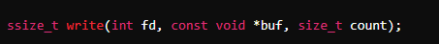
fd: File descriptor returned by open().
buf: Buffer containing the data to write.
count: Number of bytes to write.

Close():
Closes a file descriptor, freeing the resources associated with it.


Example 1: Using open(), read(), and close() to Read a File:

#include <fcntl.h>
#include <unistd.h>
#include <stdio.h>

int main() {
int fd = open("example.txt", O_RDONLY);
if (fd == -1) {
printf("Failed to open the file.\n");
return 1;
}

char buffer[100];
ssize_t bytesRead = read(fd, buffer, sizeof(buffer) - 1);
if (bytesRead == -1) {
printf("Failed to read from the file.\n");
close(fd);
return 1;
}

buffer[bytesRead] = '\0';
printf("File contents:\n%s\n", buffer);

close(fd);
return 0;
}

- #include <fcntl.h>: This header file is required for the open() system call, which is used to open files in Linux.
- #include <unistd.h>: This header file provides the declarations for the read() and close() system calls, which are used to read from and close file descriptors.
- int fd = open("example.txt", O_RDONLY);: This opens the file example.txt in read-only mode. O_RDONLY specifies that the file is to be opened for reading only.
- If the file cannot be opened (e.g., if it doesn't exist or there are insufficient permissions), open() returns -1. The program checks for this with if (fd == -1) and prints an error message, then exits with a return value of 1 to indicate failure.
- char buffer[100];: A buffer (array of characters) is declared to hold the data read from the file.
- ssize_t bytesRead = read(fd, buffer, sizeof(buffer) - 1);: The read() system call reads data from the file descriptor fd into the buffer. It reads up to sizeof(buffer) - 1 bytes (i.e., 99 bytes) to leave space for a null terminator at the end of the string. The number of bytes actually read is stored in bytesRead.
- buffer[bytesRead] = '\0';: The buffer is null-terminated by adding a null character ('\0') at the position after the last byte read.

Example 2: Using open(), write(), and close() to Read a File:

#include <fcntl.h>
#include <unistd.h>
#include <stdio.h>

int main() {
int fd = open("output.txt", O_WRONLY | O_CREAT, 0644);
if (fd == -1) {
printf("Failed to open the file.\n");
return 1;
}

const char *message = "Hello, world!\n";
ssize_t bytesWritten = write(fd, message, 14);
if (bytesWritten == -1) {
printf("Failed to write to the file.\n");
close(fd);
return 1;
}

printf("Data written successfully.\n");

close(fd);
return 0;
}

- int fd = open("output.txt", O_WRONLY | O_CREAT, 0644);: Opens or creates the file output.txt for writing.
- O_WRONLY specifies that the file is opened in write-only mode.
- O_CREAT creates the file if it does not already exist.
- 0644 sets the file permissions to rw-r--r-- (owner can read/write, group and others can read). The leading 0 indicates that the permissions are specified in octal format.
- If open() fails, it returns -1.
- ssize_t bytesWritten = write(fd, message, 14);: Writes 14 bytes from the message string to the file descriptor fd. write() returns the number of bytes written, which should match the size of the message if successful.

Inter-Process Communication:
Inter-process communication (IPC) in Linux allows processes to communicate with each other. One of the simplest forms of IPC is using unnamed pipes. Unnamed pipes are a way to allow data to be passed from one process to another in a unidirectional manner. They are often used in scenarios where you want to establish a communication channel between a parent and a child process.
A process contains everything in its address space needed for the execution. Processes can be independent or cooperating processes.

Independent Processes:
Processes operating concurrently on a systems are those that can neither affect other processes or be affected by other processes.

Cooperating Processes:
Processes that can affect or be affected by other processes. Processes may wish to communicate with each other in order to share some data.

Pipes:
One of the IPC mechanism that allow related-processes to communicate is the pipe. Also called anonymous or unnamed pipe.
Pipe allows related processes to (parent- Child) to send a data from one process to other process.

Pipe() System call:

An unnamed pipe is created using the pipe() system call, which takes an array of two file descriptors as an argument. The first file descriptor refers to the read end of the pipe, and the second refers to the write end.
Data written to the write end of the pipe can be read from the read end. The data flow is unidirectional, meaning you can only read from the read end and write to the write end.
After creating a pipe, the file descriptors can be used with standard I/O operations such as read() and write().

Example 1:
#include <stdio.h>
#include <stdlib.h>
#include <unistd.h>
#include <sys/wait.h>
#include <string.h>

int main() {
int pipefd[2];
pid_t pid;
char buf[20];
char msg[] = "Hello from parent!";

if (pipe(pipefd) == -1) {
printf("Error creating pipe\n");
exit(1);
}

pid = fork();
if (pid == -1) {
printf("Error creating process\n");
exit(2);
}

if (pid == 0) {
close(pipefd[1]);
ssize_t bytesRead = read(pipefd[0], buf, sizeof(buf));
if (bytesRead == -1) {
printf("Error reading from pipe\n");
exit(3);
}
printf("Child read: %s\n", buf);
close(pipefd[0]);
exit(0);
} else {
close(pipefd[0]);
ssize_t bytesWritten = write(pipefd[1], msg, sizeof(msg));
if (bytesWritten == -1) {
printf("Error writing to pipe\n");
exit(4);
}
close(pipefd[1]);
wait(NULL);
exit(0);
}
}

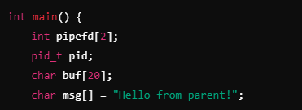

File Descriptors Array: pipefd[2] holds the file descriptors for the pipe. pipefd[0] is the read end, and pipefd[1] is the write end.
Buffers: buf is used to store data read from the pipe, and msg contains the message to be sent.
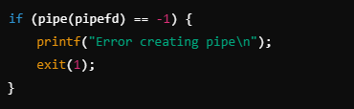
pipe(pipefd) creates a pipe. If it fails, an error message is printed, and the program exits with status code 1 else it returns 0.
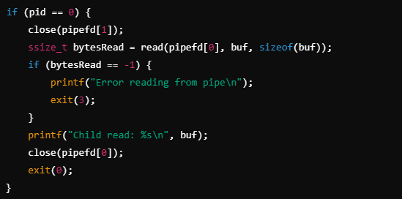

Close Write End: close(pipefd[1]) closes the unused write end of the pipe.
Read from Pipe: read(pipefd[0], buf, sizeof(buf)) reads data from the read end of the pipe into buf.
If reading fails, it prints an error message and exits with status code 3.
Print Data: printf("Child read: %s\n", buf) prints the data read from the pipe.
Close Read End: close(pipefd[0]) closes the read end of the pipe.
Exit: exit(0) exits the child process successfully.

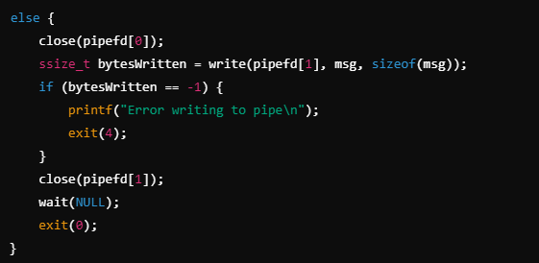

Close Read End: close(pipefd[0]) closes the unused read end of the pipe.
Write to Pipe: write(pipefd[1], msg, sizeof(msg)) writes the message to the write end of the pipe.
If writing fails, it prints an error message and exits with status code 4.
Close Write End: close(pipefd[1]) closes the write end of the pipe.
Wait for Child: wait(NULL) waits for the child process to terminate.
Exit: exit(0) exits the parent process successfully.

Output:



Example 2:

#include <stdio.h>
#include <stdlib.h>
#include <unistd.h>
#include <sys/wait.h>
#include <string.h>

int main() {
int pipe1[2];
int pipe2[2];
pid_t pid;
char parent_msg[] = "Hello from parent!";
char child_msg[] = "Hello from child!";
char buf[100];

if (pipe(pipe1) == -1) {
printf("Error creating pipe1\n");
exit(1);
}

if (pipe(pipe2) == -1) {
printf("Error creating pipe2\n");
exit(2);
}

pid = fork();
if (pid == -1) {
printf("Error creating process\n");
exit(3);
}

if (pid == 0) {
close(pipe1[1]);
close(pipe2[0]);

ssize_t bytesRead = read(pipe1[0], buf, sizeof(buf) - 1);
if (bytesRead == -1) {
printf("Error reading from pipe1\n");
exit(4);
}
buf[bytesRead] = '\0';
printf("Child received: %s\n", buf);

ssize_t bytesWritten = write(pipe2[1], child_msg, sizeof(child_msg));
if (bytesWritten == -1) {
printf("Error writing to pipe2\n");
exit(5);
}

close(pipe1[0]);
close(pipe2[1]);
exit(0);
} else {
close(pipe1[0]);
close(pipe2[1]);

ssize_t bytesWritten = write(pipe1[1], parent_msg, sizeof(parent_msg));
if (bytesWritten == -1) {
printf("Error writing to pipe1\n");
exit(6);
}

ssize_t bytesRead = read(pipe2[0], buf, sizeof(buf) - 1);
if (bytesRead == -1) {
printf("Error reading from pipe2\n");
exit(7);
}
buf[bytesRead] = '\0';
printf("Parent received: %s\n", buf);

close(pipe1[1]);
close(pipe2[0]);
wait(NULL);
exit(0);
}
}

Pipe Creation:
pipe1[2] is used for communication from the parent to the child (parent writes, child reads).
pipe2[2] is used for communication from the child to the parent (child writes, parent reads).

Child Process:
Closes the unused write end of pipe1 and the unused read end of pipe2.
Reads the message from pipe1 sent by the parent.
Writes a response to pipe2 for the parent.

Parent Process:
Closes the unused read end of pipe1 and the unused write end of pipe2.
Writes a message to pipe1 for the child.
Reads the response from pipe2 sent by the child.
The parent process waits for the child process to finish using wait(NULL).

Output:
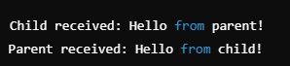

Tasks:

- Extend the example 2 to allow multiple messages to be sent back and forth between the parent and child processes.
Implement a program where the parent process sends a series of three messages to the child process through one pipe.
The child process should read each message, print it, and then send a response message back to the parent process through another pipe.
Both processes should handle multiple messages in a loop and ensure that each message is correctly sent and received. [ Estimated Time: 30 mins]

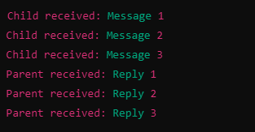

- Create multiple child processes, each communicating with the parent through shared pipes.
Implement a parent process that spawns three child processes.
Each child process should perform some simple computation (e.g., compute the square of a number) and send the result to the parent through a pipe.
The parent process should collect results from all child processes and print them.
[ Estimated Time: 45 mins]

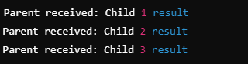

Task Submission Guidelines:
- Make a document and paste all tasks solution there (Not screenshot) and save it as pdf.
- Along with each task solution, also upload the screenshot of the output.
- Include your name and roll no. at the front page.
- Please submit your file in this format (Roll_number-name) i.e (24I-1234-Ali.pdf).
- Files other than pdf will not be accepted and will be marked as 0.

